**HTML Notes and Tags**

1. **basics.html**

*<p>* 🡪 Tag used to present **a paragraph of text** on the webpage.

*<br>* 🡪 Inserts a line break … (It’s like **\n** where it takes the cursor to the next line and starts operating from there)

*<a>* 🡪 Known as the **anchor** tag and is used to **create hyperlinks** (clickable text or elements that can take the user to another webpage, section or file)

*href* 🡪 It stands for **hyperlink reference**. Defines the URL or destination the link points to

href = “https://www.flipkart.com” tells the browser where to go when the link is clicked.

flipboi is nothing but the reference on which we click to direct to a particular website

*<img src = “… ” >* 🡪 Displays an image on the web page using a source link.

{Click on the image 🡪 Copy image address 🡪 put inside the double quotes of the img src}

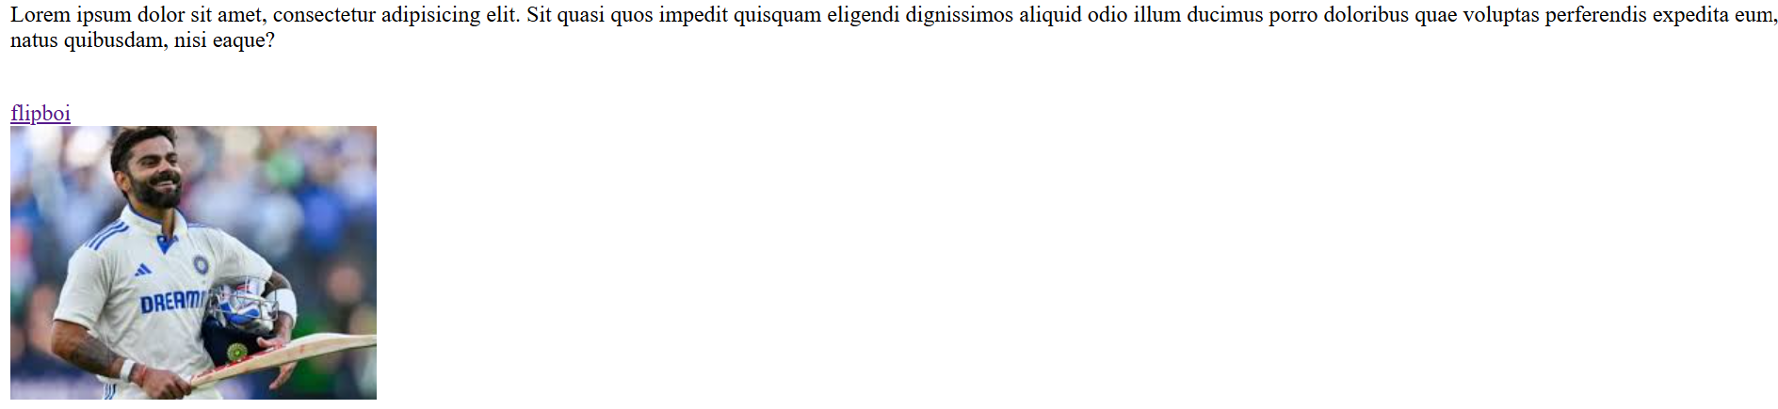

1. **table.html**

*<style>* 🡪 Contains CSS rules to style elements within the HTML document

*<table>* 🡪 Defines a table to organize data in rows and columns.

*<tr>* 🡪 Stands for **table row** and defines row inside the table

*<th>* 🡪 Stands for **table header** and defines a header cell (usually bold and **centered** by default)

*<td>* 🡪 Stands for table data and defines a regular cell containing data in the table

*OUTPUT:*

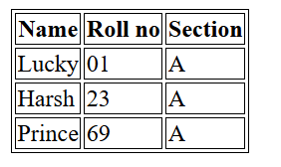

***{border: 1px solid black;}***🡪Adds a solid black border of 1 pixel to the specified elements (th, td, and table).

1. **timetable.html**

*rowspan=”2”* 🡪 Merges the cell vertically across n rows. Here n = 2

*colspan=”2”* 🡪 Merges the cell horizontally across n columns. Here n = 2

*OUTPUT:*

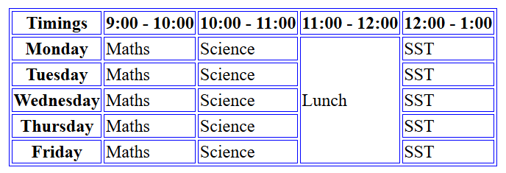

1. **marks.html**

*OUTPUT:*

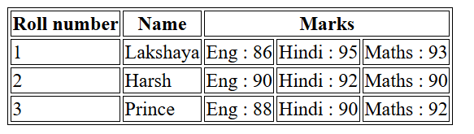

1. **teacher.html**

*OUTPUT:*

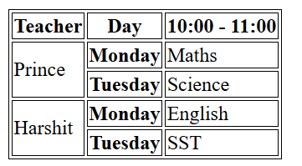

1. **exam.html**

*width*🡪 Sets column width to a particular **px** size as mentioned

*OUPUT:*

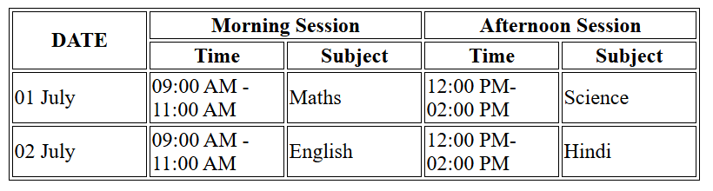

1. **bustime.html**

*OUTPUT:*

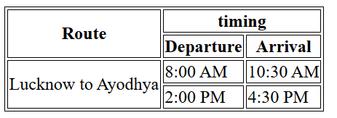

1. **students.html**

style=”text-align: right;”: Aligns the elements to the right side using inline CSS.

*OUTPUT:*

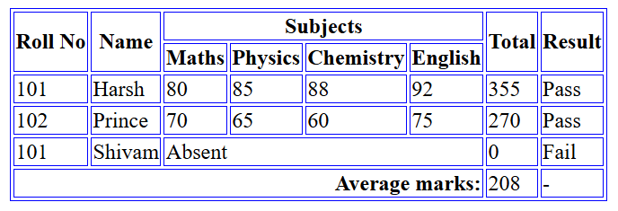

1. midterm.html

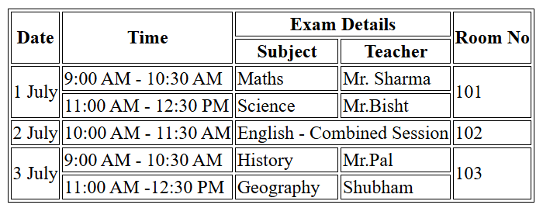

1. invoice.html

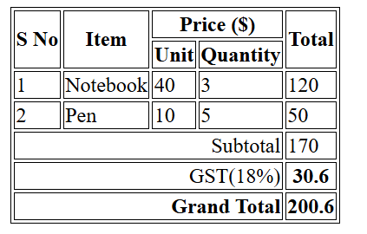

1. teamalpha.html

